JAVA PROGRAMMING LAB
PROGRAM 1-20
1.Print integer entered by user.
ans
import java.util.Scanner;
class Main{
public static void main (String[]args)
{
Scanner sc=new Scanner(System.in);
System.out.println("Enter an integer:");
int n=sc.nextInt();
System.out.println("The integer is:"+n);
}
}
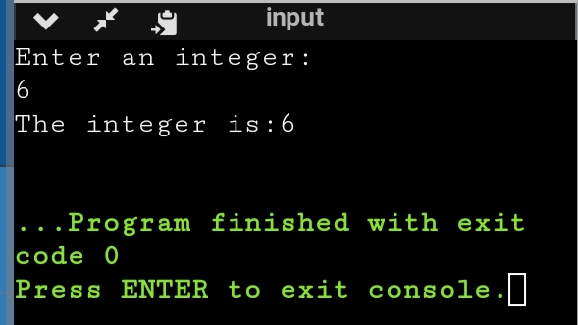
2.Usage of primitive data type
ans
import java.util.Scanner;
public class Main
{
public static void main(String[] args) {
Scanner sc=new Scanner(System.in);
System.out.println("Enter an integer:");
int n=sc.nextInt();
System.out.println("The integer is"+n);
System.out.println("Enter float value :");
float m=sc.nextFloat();
System.out.println("Floating value is:"+m);
System.out.println("Enter the Boolean value:");
boolean t=sc.nextBoolean();
System.out.println("The boolean value is "+t);

}
}
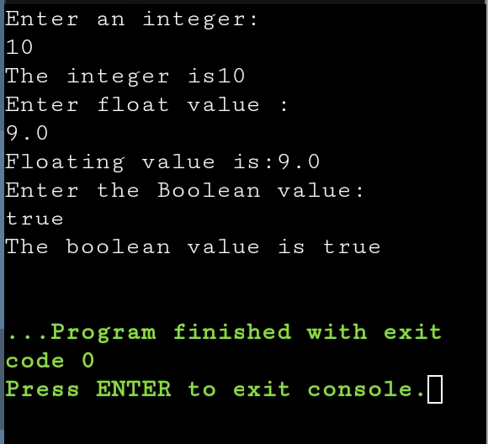
3.Swap two numbers using temporary variable
ans
import java.util.Scanner;
public class Main
{
public static void main(String[] args) {
Scanner sc=new Scanner(System.in);
System.out.println("Enter first number:");
int a=sc.nextInt();
System.out.println("Enter second number:");
int b=sc.nextInt();
int c;
c=a;
a=b;
b=c;
System.out.println("After Swapping :");
System.out.println("First no. is-"+a);
System.out.println("Second no. is-"+b);
}
}

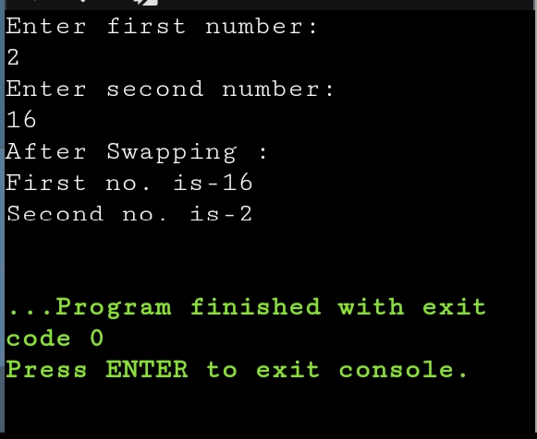
4.Check whether a number is odd or not using if else statement
ans
import java.util.Scanner;
public class Main
{
public static void main(String[] args) {
Scanner sc=new Scanner(System.in);
System.out.println("Enter a number:");
int a=sc.nextInt();
if(a%2==0)
System.out.println("Even Number");
else
System.out.println("Odd Number");
}
}
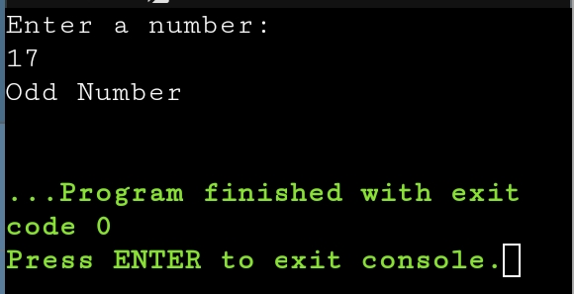
5.Vowel or consonant
ans
import java.util.Scanner;
public class Main
{
public static void main(String[] args) {
Scanner sc=new Scanner(System.in);
System.out.println("Enter a character:");
char ch;
ch=sc.next().charAt(0);
if(ch=='a'||ch=='e'||ch=='i'||ch=='o'||ch=='u'||ch=='A'||ch=='E'||ch=='I'||
ch=='O'||ch=='U')
System.out.println("Vowel");
else
System.out.println("Consonant");
}
}
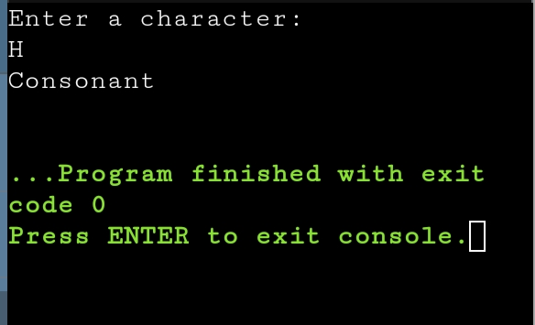
6.Check whether number is positive or negative
ans
import java.util.Scanner;
public class Main
{public static void main(String[] args) {
Scanner sc=new Scanner(System.in);
System.out.println("Enter a number:");
int n=sc.nextInt();
if(n>=1)
System.out.println("Positive");
else if(n==0)
System.out.println("Neither positive nor negative ");
else
System.out.println("Negative");
}}
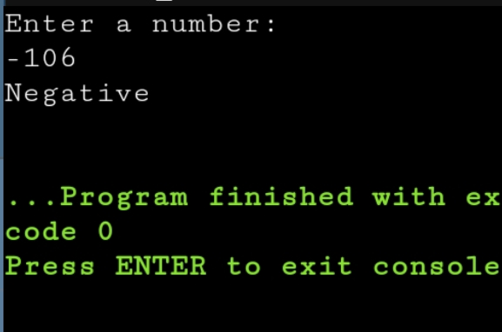
7.Sum of natural number using for loop
ans
import java.util.Scanner;
public class Main
{
public static void main(String[] args) {
Scanner sc=new Scanner(System.in);
System.out.println("Enter no of terms:");
int n=sc.nextInt();
int sum=0;
for(int i=1;i<=n;i++)
{
sum+=i;
}
System.out.println("Sum of n natural number"+sum);}
}
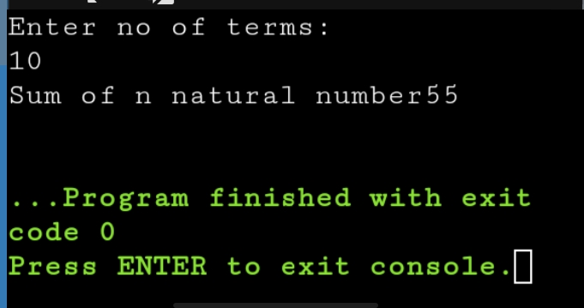
8.Factorial of a number using for loop.
ans
import java.util.Scanner;
public class Main
{
public static void main(String[] args) {
Scanner sc=new Scanner(System.in);
System.out.println("Enter a number:");
int n=sc.nextInt();
int fact=1;
for(int i=1;i<=n;i++)
{
fact*=i;
}
System.out.println("Factorial of number is"+fact);
}
}
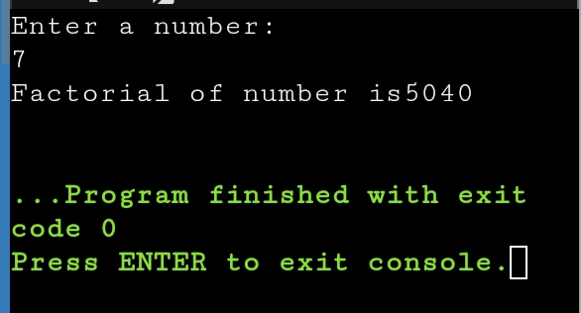
9.Multiplication Table
ans
import java.util.Scanner;
public class Multiplication{
public static void main(String[] args){
Scanner sc=newScanner(System.in);
System.out.println("Enter a number");
int n=sc.nextInt();
for(int i=1;i<=10;i++)
{
System.out.println(n+"x"+i+"="+n*i);
}

}

}
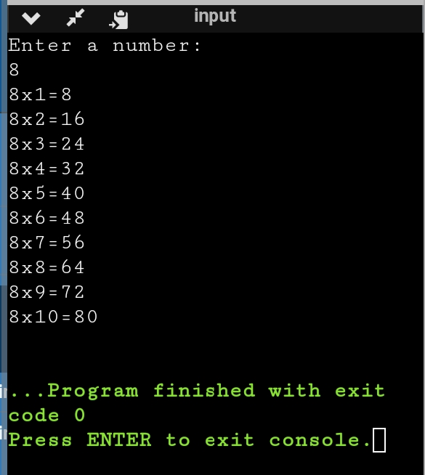
10.Display uppercase alphabet from A to Z using for loop
ans
import java.util.Scanner;
public class Main
{
public static void main(String[] args) {
Scanner sc=new Scanner(System.in);
System.out.println("Upper-case alphabet from A to Z are:");
char ch;
for(ch='A';ch<='Z';ch++)
{
System.out.print(ch+" ");

}
}
}
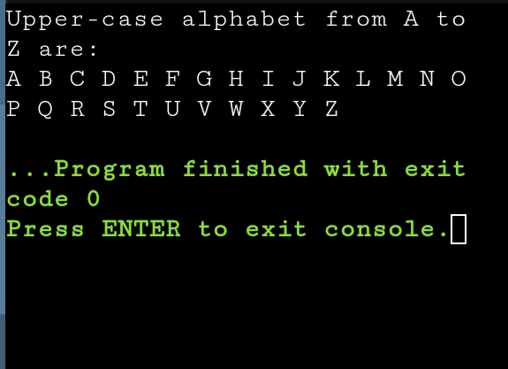
11.Find gcd of two numbers using for loop and if statement
ans
import java.util.Scanner;
public class Main
{
public static void main(String[] args) {
Scanner sc=new Scanner(System.in);
System.out.println("Enter first number:");
int a=sc.nextInt();
System.out.println("Enter second number:");
int b=sc.nextInt();
int GCD=1;
for(int i=1;i<=a&&i<=b;i++)
{
if(a%i==0&&b%i==0)
GCD=i;
}
System.out.println("GCD of two entered number is:"+ GCD);

}
}
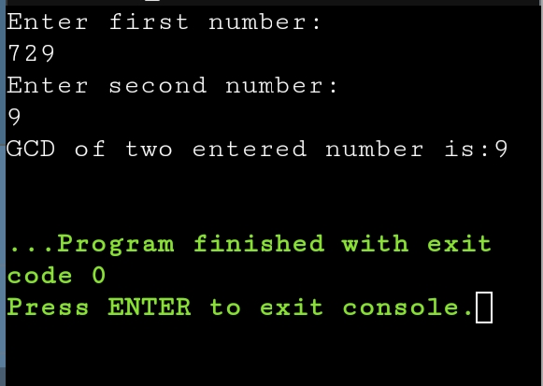
12.Reverse the number
ans
import java.util.Scanner;
public class Main
{
public static void main(String[] args) {
Scanner sc=new Scanner(System.in);
System.out.println("Enter a number:");
int a=sc.nextInt();
int rev=0,q;
while(a!=0)
{
q=a%10;
rev=(rev*10)+q;
a=a/10;
}
System.out.println("Reverse of number is:"+ rev);

}
}

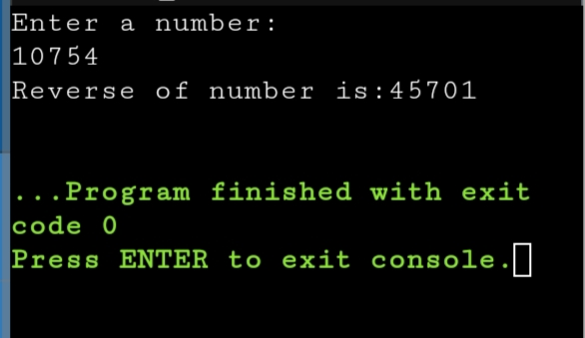
13.Demonstrate creating class and instance (object).
ans
class Student{
int id;
String name;
public static void main(String[] args)
{
Student s1=new Student();
System.out.println(s1.id);
System.out.println(s1.name);

}

}
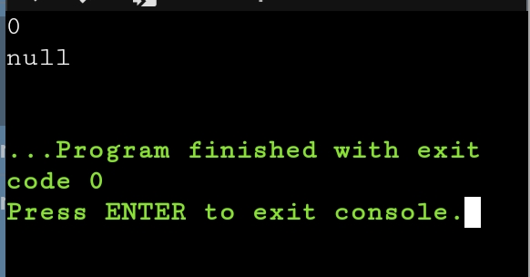
14.Demonstrate using instance/class variable in a java program by creating a simple public class.
ans
public class Studentsrecords
{
public String name;
public Studentsrecords(String sname)
{
name = sname;
}
public void printstud()
{
System.out.println("Student Name: " + name );
}
public static void main(String args[])
{
Studentsrecords s = new Studentsrecords("Monica");
s.printstud();
}
}
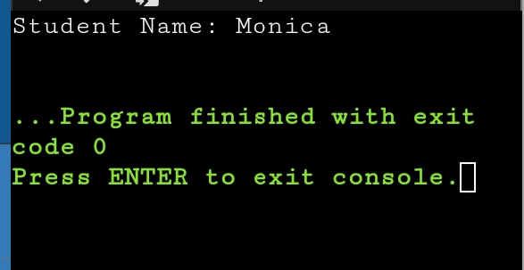

15.Demonstrate the java class using getter setter method for accessing private data member .
ans
class Student{
private String name;
private int rollno;
public void setName(String n) {
name=n;
}
public String getName() {
return name;
}
public void setRollno(int r) {
rollno=r;
}
public int getRollno() {
return rollno;
}
}
public class Main{
public static void main(String[] args){
Student s1=new Student();
s1.setName("ABC");
s1.setRollno(36);
System.out.println(s1.getName());
System.out.println(s1.getRollno());
}

}
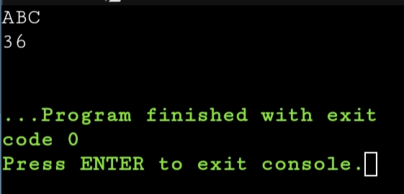
16.Demonstrate the use of static variable
ans
class VariableDemo
{
static int count=0;
public void increment()
{
count++;
}
public static void main(String args[])
{
VariableDemo obj1=new VariableDemo();
VariableDemo obj2=new VariableDemo();
obj1.increment();
obj2.increment();
System.out.println("Obj1: count is="+obj1.count);
System.out.println("Obj2: count is="+obj2.count);
}
}
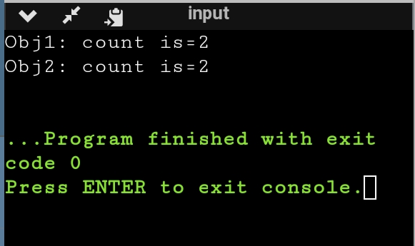
17.Demonstrate the use of static method.
ans
class StaticTest {
static int add(int a, int b){
return a + b;
}
}

public class Main {

public static void main( String[] args ) {
StaticTest st = new StaticTest();
System.out.println(" 2 + 3 = " + StaticTest.add(2,3));
}
}
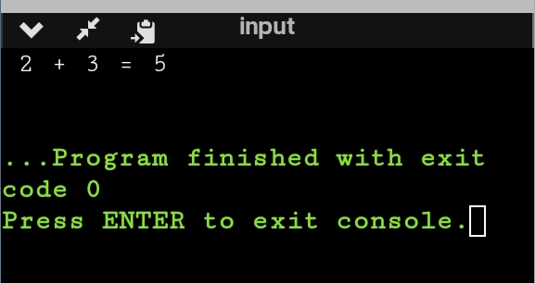
18.Demonstrate the use of Scanner class for taking input/output from user.
ans
import java.util.Scanner; public class A{ public static void main(String args[]){ System.out.println("Enter any number: "); Scanner sc=new Scanner(System.in); int n=sc.nextInt(); System.out.println(n); } }
19. Light program:
ans
import java.util.Scanner; public class Light{ boolean isOn; void switchOn(){ isOn=true; System.out.println(isOn); } void switchOff(){ isOn=false; System.out.println(isOn); } public static void main(String args[]){ Light led=new Light(); Light halogen=new Light(); led.switchOn(); halogen.switchOff(); System.out.println(led.isOn); } }

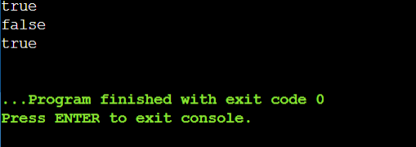

20. Box Program:-
ans
public class Box{ private int height; private int length; private int breadth; Box(){ height=0; length=0; breadth=0; } Box(int height, int length, int breadth){ this.height=height; this.length=length; this.breadth=breadth; } public int Volume(){ return(length*breadth*height); } public static void main(String args[]){ Box cuboid1=new Box(); System.out.println("The area of the cuboid is" + cuboid1.Volume()); Box cuboid2=new Box(10,15,30); System.out.println("The area of cuboid is"+ cuboid2.Volume()); } }
